DESARROLLO DEL MODULO DE ingleS

ANGELA NICOL BARRERA HURTADO

INSTITUCION EDUCATIVA
EDUCAMOS CON VALORES
2024
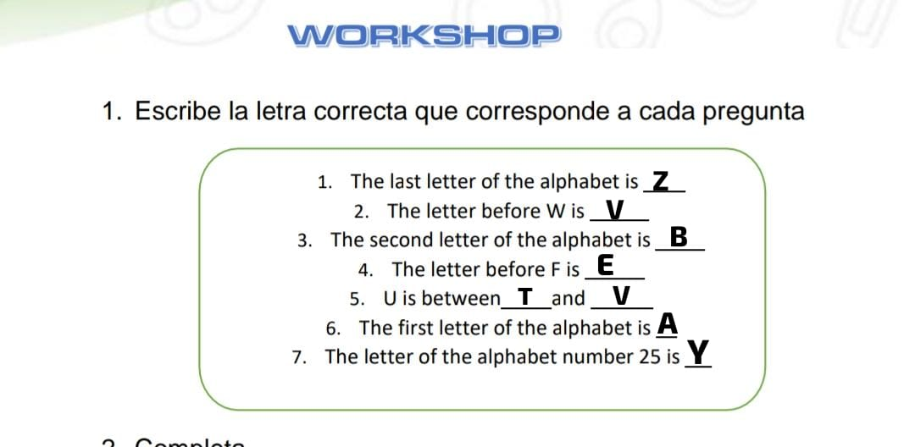

2
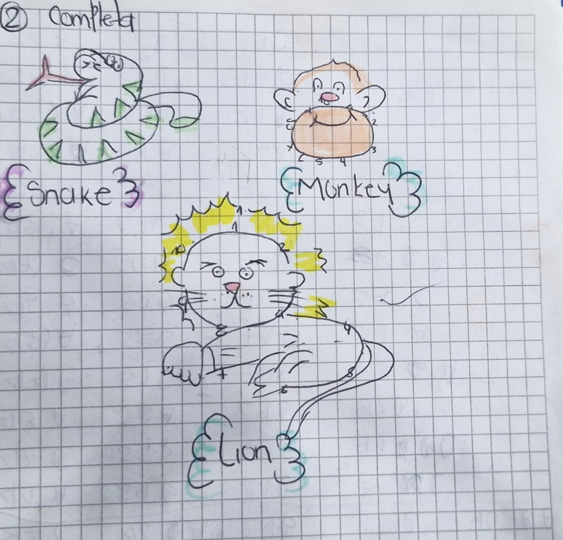

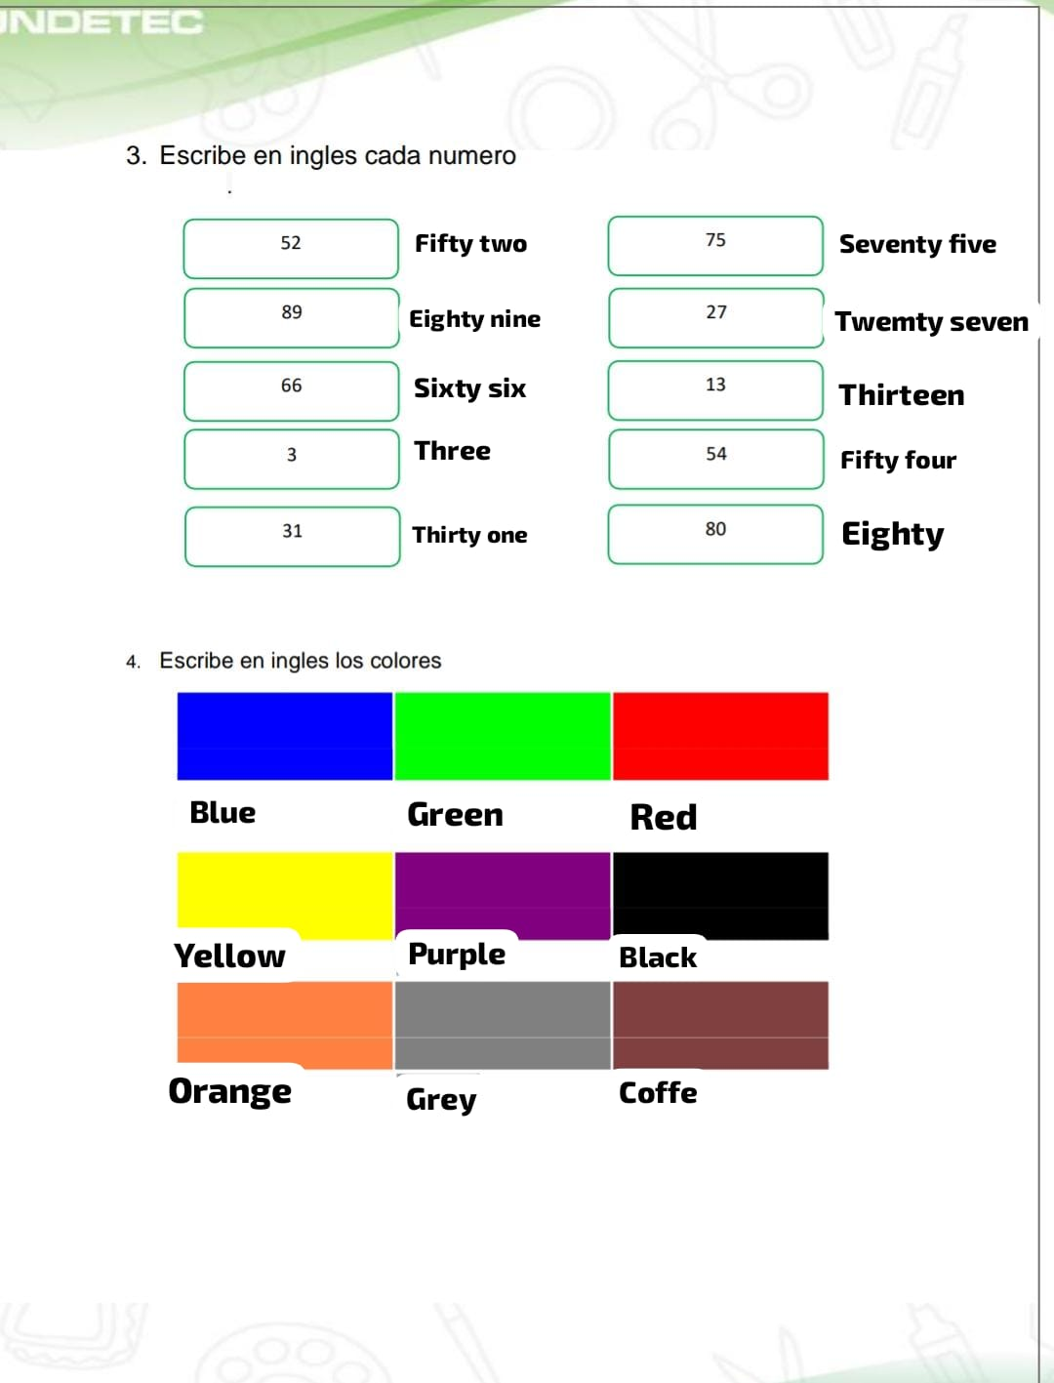

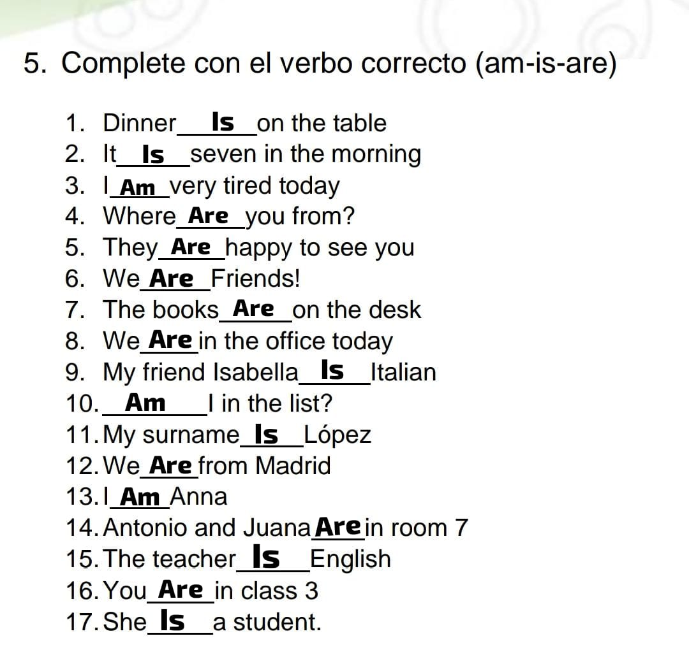

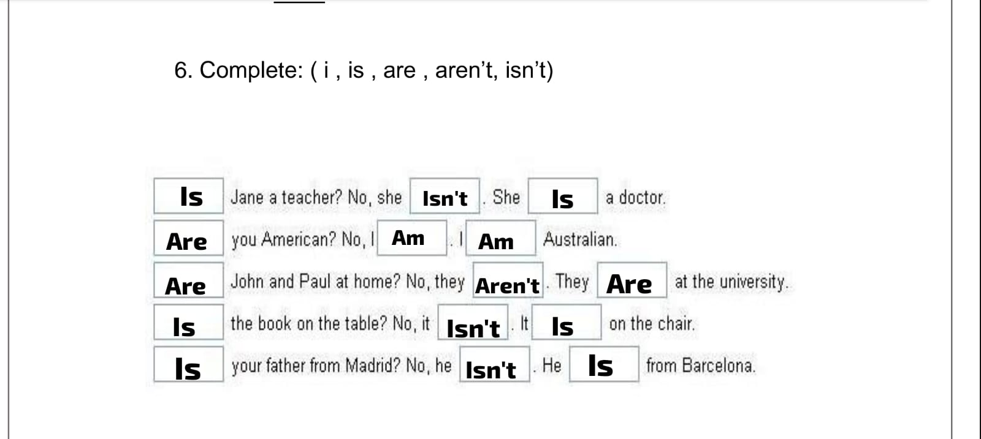

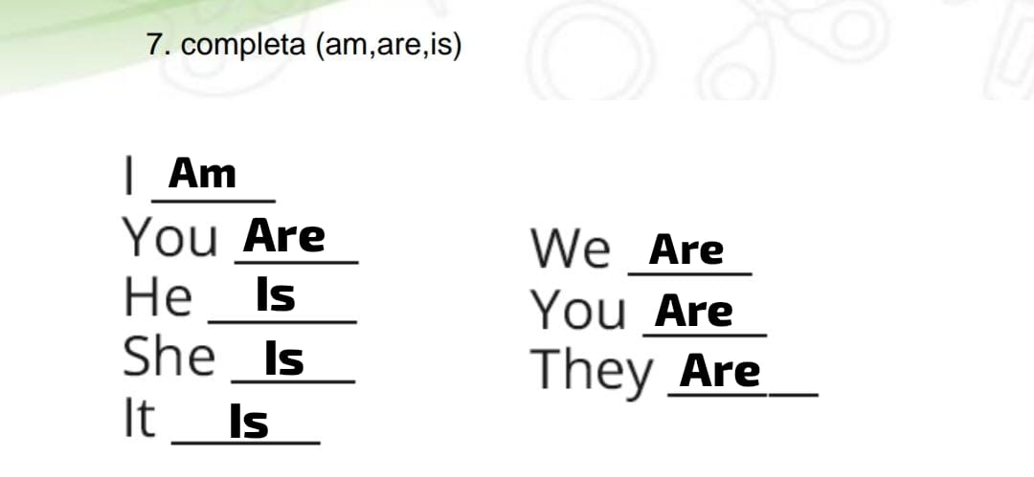

8. Escribe las frases en inglés
where was I yesterday at 4
I was at school until 8
There was good weather yesterday
I'm hungry ¿Can I eat something?
sofia is happy
Juan and Camilo are sick
On Friday I was desperate
my brother works in miami
Carolina is in the room
My house is beautiful

9.Escribe el tiempo correcto
1. Joh Talking to Mary now (talk)
2. In Watch televisión every night. (watch)
3.The children usually Goes to bed at nine o’clock. (go)
4. Reading a book at the momento? (Read)
5.I Am not studying at the momento. (not study)
6.I Don´t speak English, although I Studying at the moment. (not speak)/(study)
7.I Was living In Valencia, though I Staying in Madrid at the moment. (live)/ (stay)
8.I Staying in a hotel at the moment, although I have my own apartment. (stay)/ (have)
9. She IS from Chle, though she Is living in New York just now. (come)/ (live )

10. Completa el cuadro con las conjugaciones del verbo To be
1.My name is James
2.Mary is the secretary.
3.Jhon and Lucy Are at school
4.I Am a student
5.The boys Are in the garden
6.He is a lawyer
7.Susie is a housewife
8. She is a student.
9. They Are my friends.

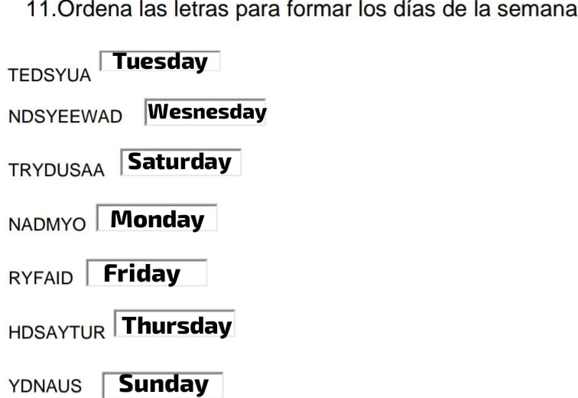

12. Construye las siguientes frases en el recuadro de abajo.
Happy/You/are
You are happy

Lives/she/New York
She lives in New York

Don´t/like/I/ice cream
I don’t like ice cream

a/they/dog/got/have
They have got a dog

not/is/tired/he
He is not tored

we/Spain/don’t/live/in
we don’t live spain

got/car/has/he/a/?
He has got a car

are/happy/?/they
They are happy

hands/your/wash/
your hands wash

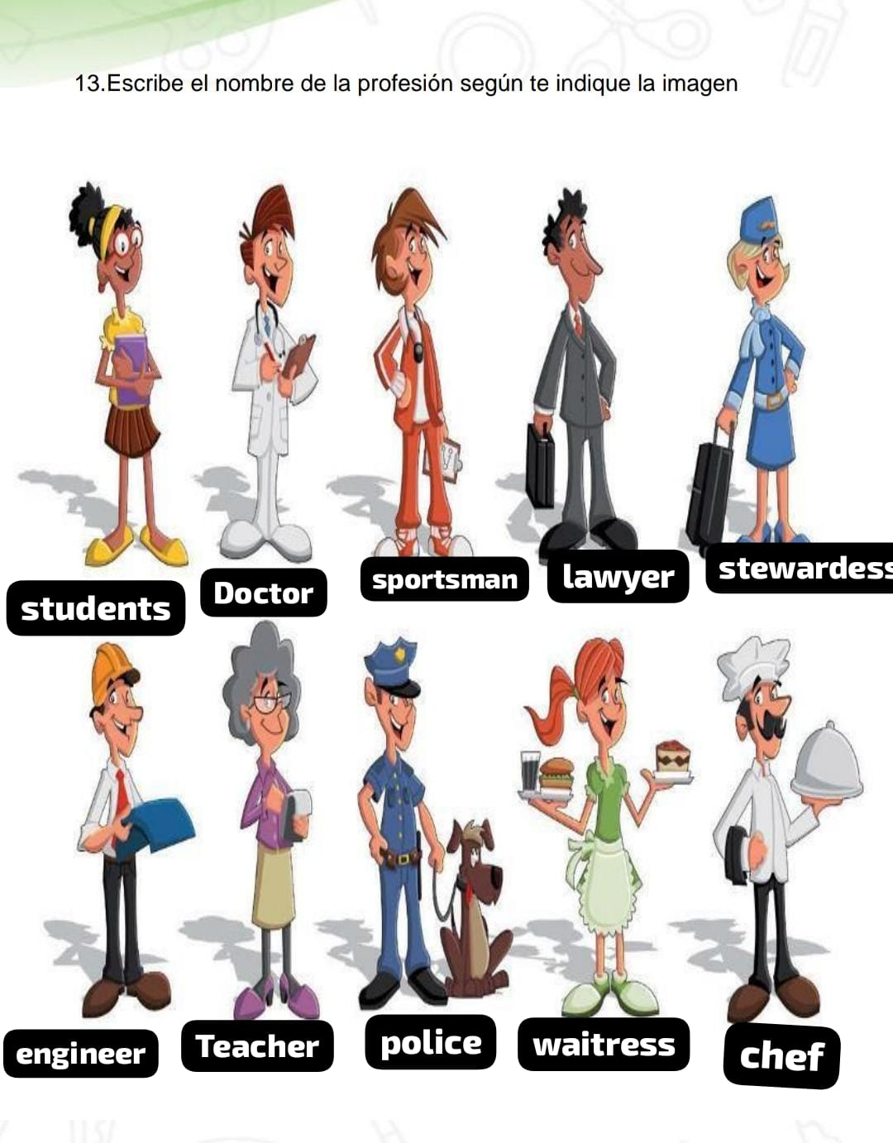

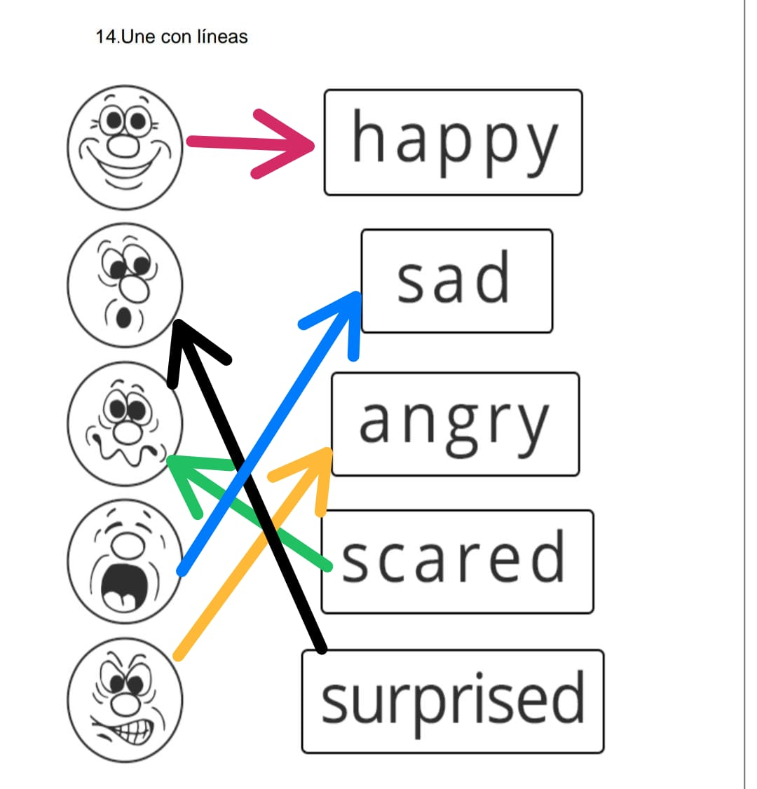

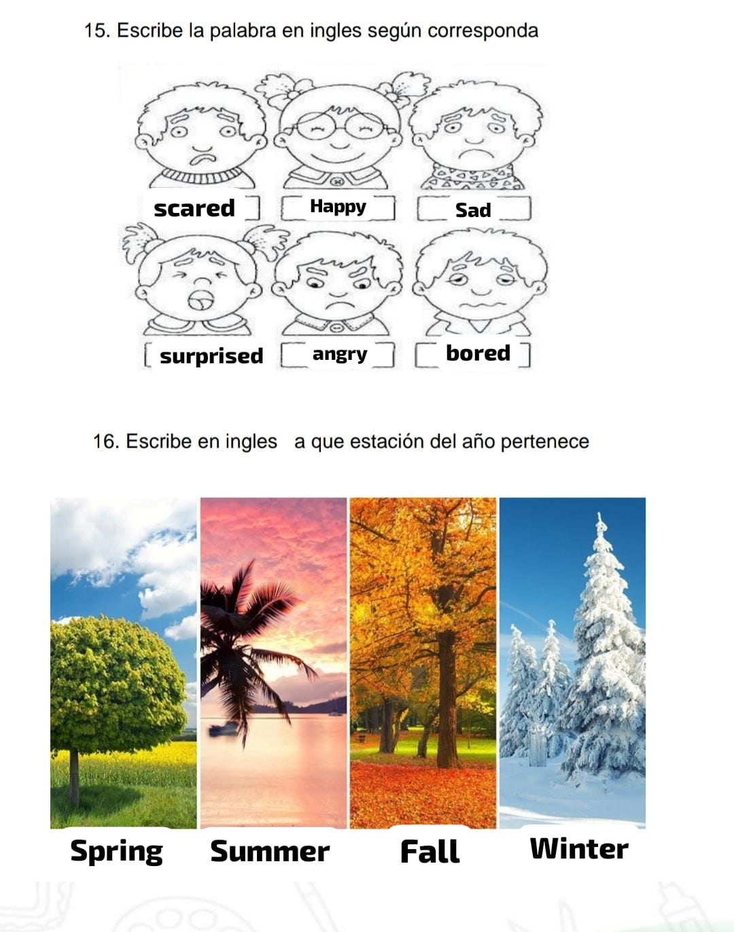

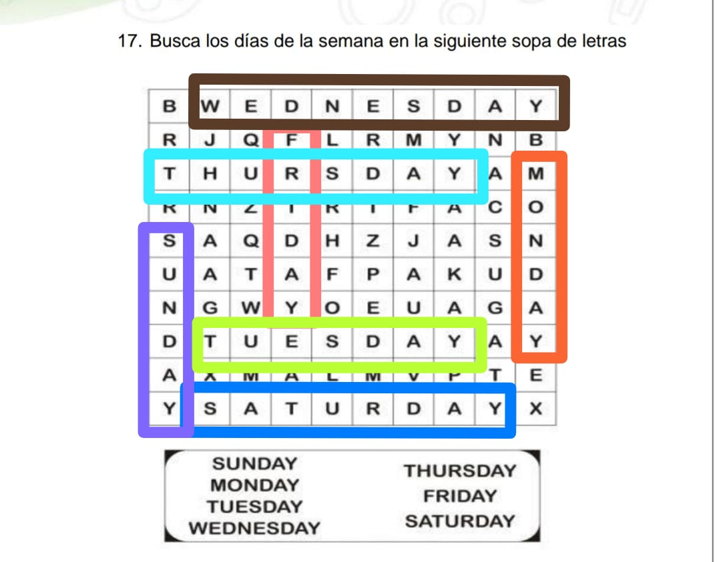

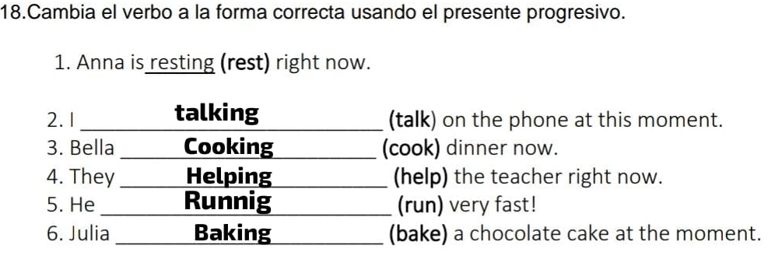

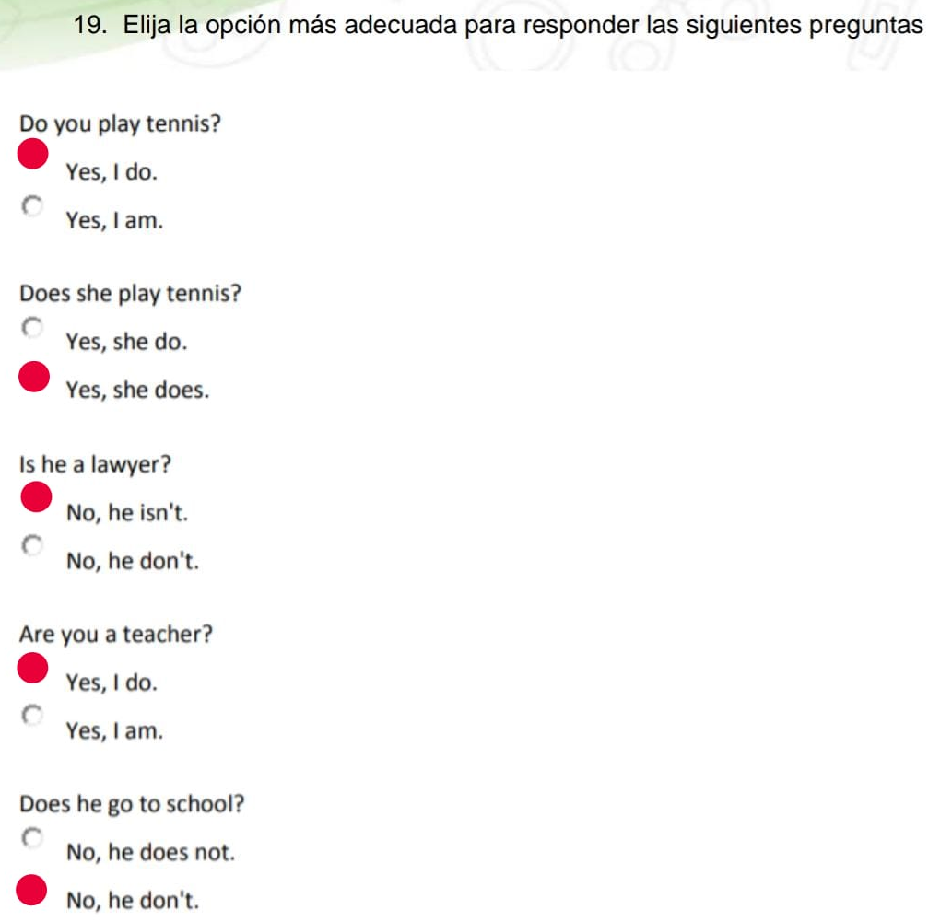

Punto 20
They we you i se pones don't
He doesn't live in london
You aren't good
She isn't a teacher
They don't live in england
Joe isn't a doctor
Mary isn't a lawyer
They haven't two car
We aren't in london

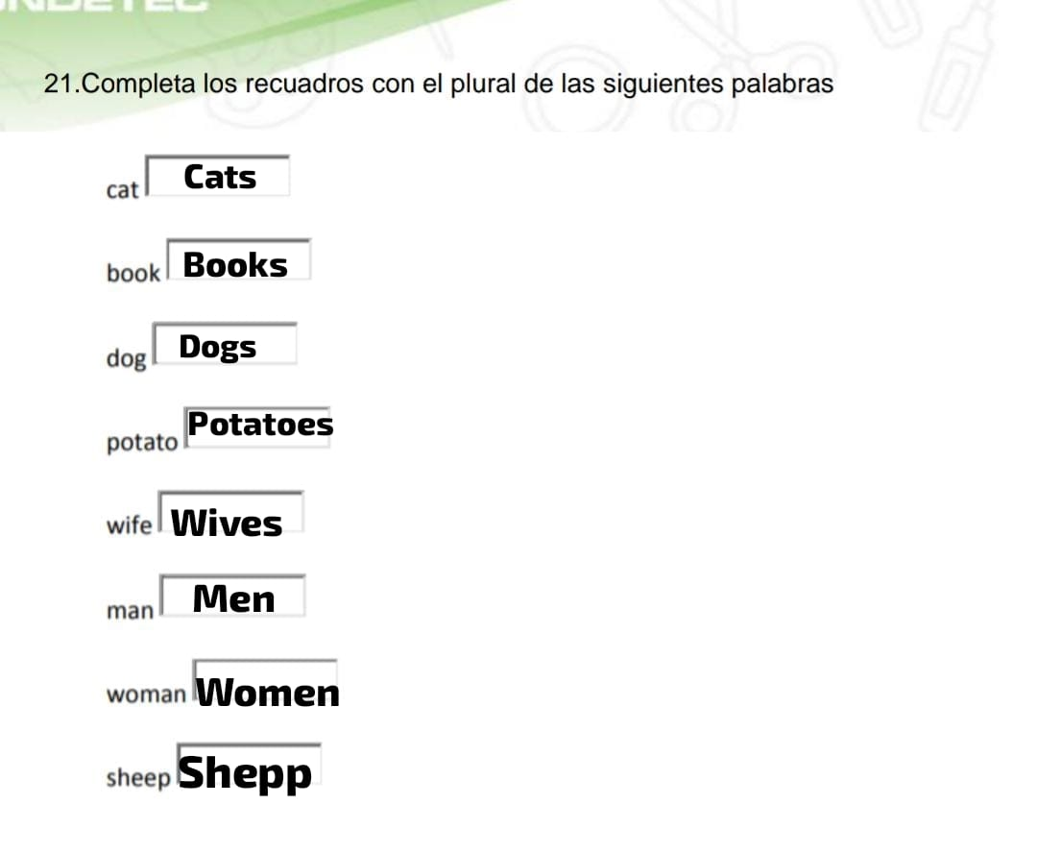

22. Oraciones afirmativas
The apple is on the table
You should go to the dentist
They ’ve bought a new car.
Peter had seen her before
You are my friend
We are good people

Oraciones interrogativa
Where is her house?
Which is your notebook?
Why are you awake?
Which is your notebook?
Who is your mother?
When is your graduation?

23. Escribe los números de 10 en 10 hasta 100.
10. TEN
20. TWENTY
30. THIRTY
40. FORTY
50. FIFTY
60. SIXTY
70. SEVENTY
80. EIGHTY
90. NINETY
100. ONE HUNDRED

